**DAYANANDA SAGAR UNIVERSITY**

**DEPARTMENT OF COMPUTER SCIENCE & ENGINEERING SCHOOL OF ENGINEERING**

**KUDLU GATE BANGALORE - 560068**



**MINI PROJECT REPORT**

**ON**

**“HOME LIGHTING AUTOMATION”**

(**SUBMITTED TO THE 3RD SEMESTER ELECTRONIC CIRCUITS LABORATORY-2018)**

***Submitted by***

KUNAL GUPTA (ENG17CS0113)

KUSHAL N (ENG17CS0115) MANOJ MR (ENG17CS0123)

MANOJKUMAR M MANGALORE (ENG17CS0124)

MOHAMMED ZAHID PASHA (ENG17CS0129)

***Under the supervision of* Prof. RANJINI Assistant Professor,**

**Dept of CSE, Dayananda Sagar University.**

1

**DECLARATION**

We hereby declare that the work presented in this mini project entitled-**“ Home Lighting Automation”** has been carried out by us and it has not been submitted for the award of any degree, diploma or the mini project of any other college or university.

KUSHAL N (ENG17CS0115)

2

**ACKNOWLEDGEMENT**

The satisfaction that accompanies the successful completion of task would be incomplete without the mention of the people who made it possible and whose constant guidance and encouragement crown all the efforts with success.

We are especially thankful to our **Chairman, Dr. M. K. Banga**, for providing necessary departmental facilities, moral support and encouragement.

We are very much thankful to **Prof. Ranjini K**, for providing help and suggestions in completion of this mini project successfully.

We have received a great deal of guidance and co-operation from our friends and we wish to thank all that have directly or indirectly helped us in the successful completion of this project work

KUSHAL N (ENG17CS0115)

3

**TABLE OF CONTENTS**

Contents Page no

CHAPTER 1: INTRODUCTION 6

CHAPTER 2: HARDWARE & 7

SOFTWARE REQUIREMENTS

CHAPTER 3: DESIGN 11

METHODS

CHAPTER 4: MODULE 12

DESCRIPTION

CHAPTER 5: APPLICATIONS AND

UNIQUENESS OF THE PROJECT 15

CHAPTER 6: LIMITATION 16

**ABSTRACT**

The fear of theft and burglary always annoys many people. When lock and keys become less safe, one can seek the help of electronic security systems.Such a portable security system is described here. This electronic setup auto activated whenever the intruder enters to the unauthorized no entry area. It auto activate the landline number and redial the last dialed number from the conventional telephone. All we need is to do minor changes to activate this telephone as it works as to become auto dialer circuit.Thus whenever the intruder enters to the area, it activates the sensor circuit of either sound activation or infrared light beam obstruction circuit, the redial circuit become active and give a ring tone to the receiving end. It may be a mobile phone or any landline phone or even police control room.

5

**CHAPTER-1**

**INTRODUCTION**

This will determines whether the object is get into it (for example:- room) or goes out, for that we are using a two IR sensors which will sense the object and if it is coming inside that then the system will show Enter 1, if another person enters it will show Enter 2,suppose if they goes out the number will be reduced one by one,this is because when the first object detected by sensors the count will be increased to one, similarly for 2,3,and so on as soon as the object exit the count starts decreasing one by one.Finally we will be having a correct figure of objects how many are there inside the room.Wastage of electricity is one of the main problems which we are facing now-a-days. In our home, school, colleges or industry we see that fan/lights are kept on even if there are nobody in the room or area/passage. This happens due to negligence or because we forgot to turn lights off or when we are in hurry. To avoid all such situations we have designed this project called “ Home Lightning Automation ” .Our Project measures the number of persons entering in any room like seminar hall, conference room, classroom. This function is implemented using a pair of *Infrared sensors*. This person count will be incremented if somebody enters in the room and at that time lights are turned on. And in a reverse way, person count will be decremented if somebody leaves the room. When the number of persons inside the room is zero, lights inside the room are turned off using a relay interface.Since this project uses 2 infrared sensors, it can be used as Bidirectional person counter as well.

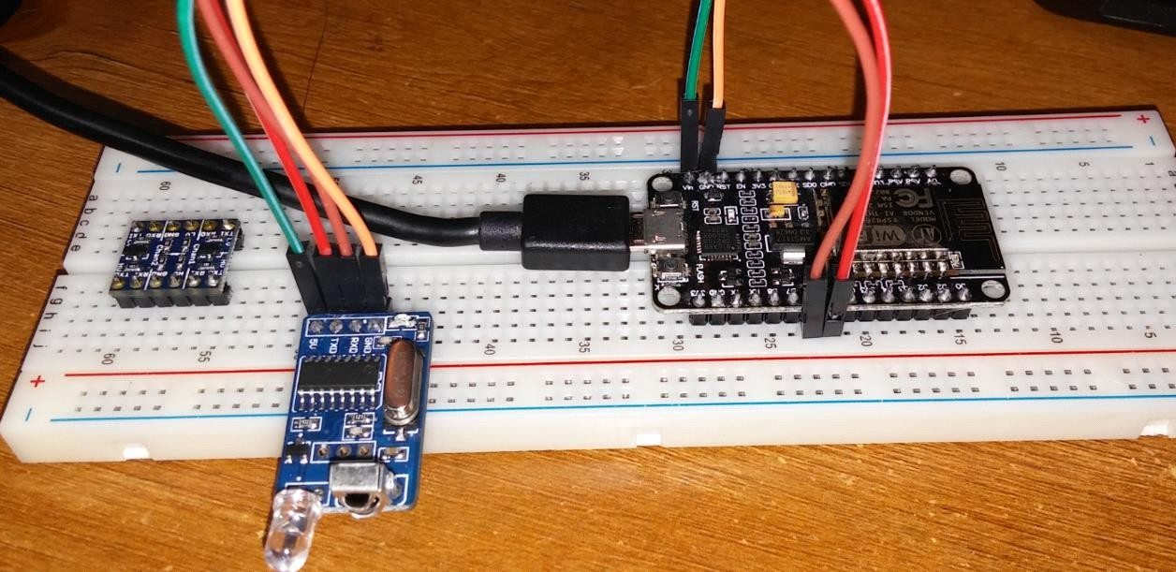

**CHAPTER-2**

**HARDWARE AND SOFTWARE REQUIREMENTS**

**HARWARE REQUIREMENTS:**

ESP8266 ESP-12E for arduino CP2102

5v Relay

2 IR sensors

1 breadboard

connecting wires

NodeMCU ESP8266 ESP-12E for arduino CP210

**NODE MCU :(ESP8266)**

Its basically an SoC (System on Chip)

A System on a Chip or System on Chip(SoC) is an integrated circuit that integrates all components of a computer or other electronic systems.

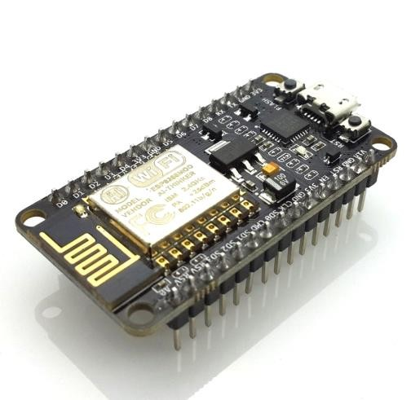

**IR SENSORS :**

An infrared sensor is an electronic device, that emits in order to sense some

aspects of the surroundings. An IR sensor can measure the heat of an object as well as detects the motion.These types of sensors measures only infrared radiation, rather than emitting it that is called as a passive IR sensor. Usually in the infrared spectrum, all the objects radiate some form of thermal radiations. These types of radiations are invisible to our eyes, that can be detected by an

infrared sensor.The emitter is simply an IR LED (Light Emitting Diode) and the detector is simply an IR photodiode which is sensitive to IR light of the same wavelength as that emitted by the IR LED. When IR light falls on the photodiode, The resistances and these output voltages, change in proportion to the magnitude of the IR light received.

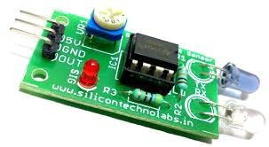

**RELAY :**

A relay is an electrically operated switch. Many relays use an electromagnet to

mechanically operate a switch, but other operating principles are also used, such as solid-state relays. Relays are used where it is necessary to control a circuit by a separate low-power signal, or where several circuits must be controlled by one

signal. The first relays were used in long distance telegraph circuits as amplifiers: they repeated the signal coming in from one circuit and re-transmitted it on another circuit. Relays were used extensively in telephone exchanges and early computers to perform logical operations.

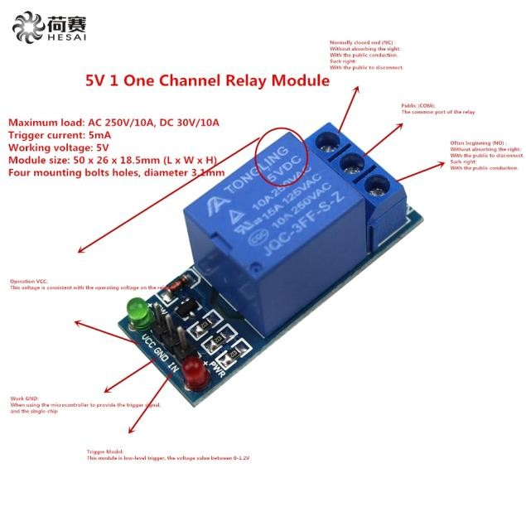

**BREADBOARD :**

A breadboard is a construction base for prototyping of electronics. Originally it

was literally a bread board, a polished piece of wood used for slicing bread. In the 1970s the solderless breadboard (a.k.a. plugboard, a terminal array board)

became available and nowadays the term "breadboard" is commonly used to refer to these.

Because the solderless breadboard does not require soldering, it is reusable. This

makes it easy to use for creating temporary prototypes and experimenting with circuit design. For this reason, solderless breadboards are also popular with students and in technological education. Older breadboard types did not have this property. A stripboard (Veroboard) and similar prototyping printed circuit boards, which are used to build semi-permanent soldered prototypes or one-offs, cannot easily be reused. A variety of electronic systems may be prototyped by using

breadboards, from small analog and digital circuits to complete central processing units (CPUs).

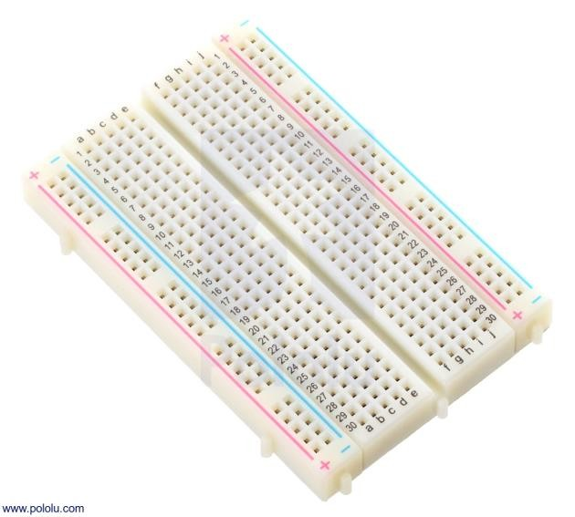

**JUMPER WIRES :**

A jump wire (also known as jumper wire, or jumper) is an electrical wire, or group

of them in a cable, with a connector or pin at each end (or sometimes without them – simply "tinned"), which is normally used to interconnect the components

of a breadboard or other prototype or test circuit, internally or with other equipment or components, without soldering.[1]

Individual jump wires are fitted by inserting their "end connectors" into the slots provided in a breadboard, the header connector of a circuit board, or a piece of

test equipment**.**

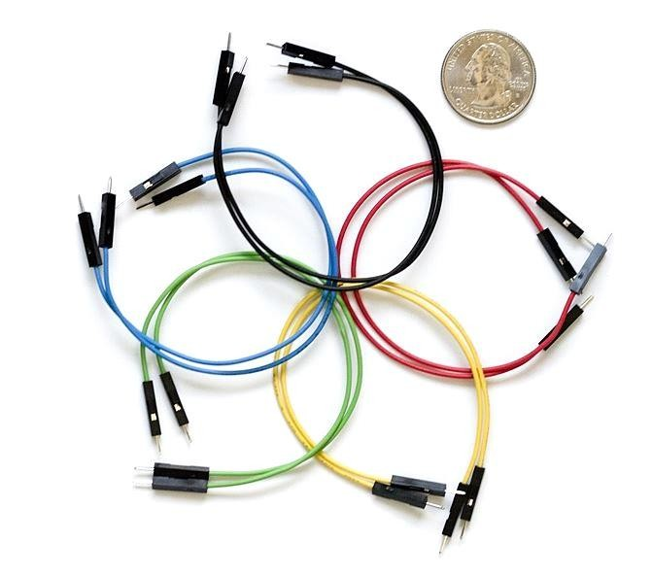

**SOFTWARE REQUIREMENTS:**

Arduino IDE

7

**CHAPTER-3**

**DESIGN METHOD**

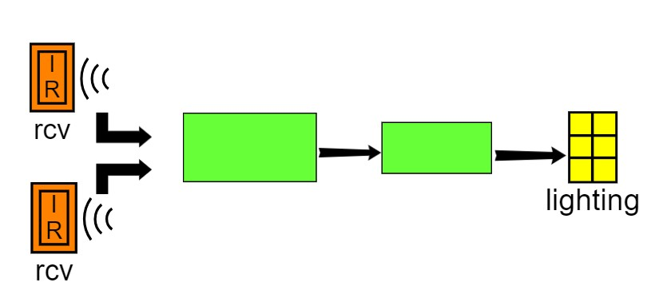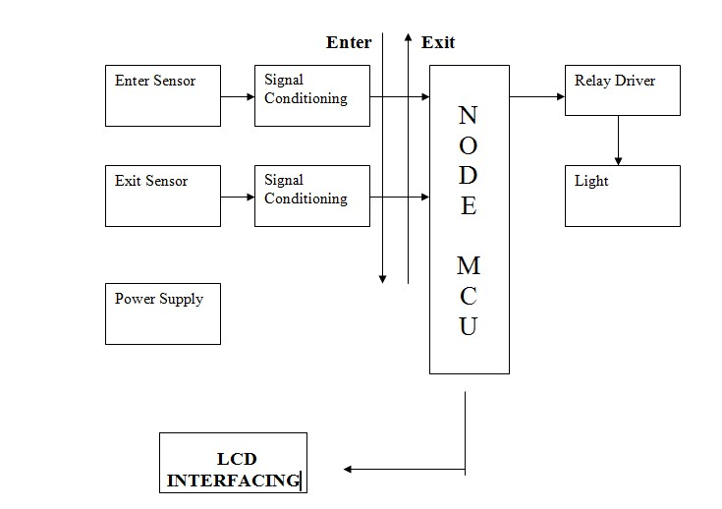

11

**CHAPTER-4**

**MODULE DESCRIPTION**

Consider we have IR1 and IR2 . Each of the IRs are associated with a variable ( say x and y respectively) . By default both are set to 1 - which means both IRs are active .

Assuming that the entry is taken when the person moves from IR1 to IR2

Case 1 : IR1 detects the object - x becomes 2 . This means that further only IR2 is active till it encounters an object . When it does . The count is incremental by one and x is reseted to 0

Case 2 : IR2 detects the object - y becomes 2 . This means that further only IR1 is active till it encounters an object . When it does , someone has exited the room

.The count is decremental by one and y is reseted to 0

Whenever the count equals 0 the relay is turned off which means the light are off and whenever the count is not equal to 0 the lights are on .

**CODE**:

#define CLK 12 //It is D6

#define DIO 13 //It is D7 const int ProxSensor1=5;// d1 const int ProxSensor2=4;// d2 const int relay = 2; //d4 = time2

//time1-time2> 0 : Enter

//time1-tim2 <0 : Exit

int wait = 0; int count = 0; int i = 0;

void setup()

{

pinMode(LED_BUILTIN, OUTPUT); // Pin 13 has an LED connected on most

Arduino boards:

pinMode(ProxSensor1,INPUT);

pinMode(ProxSensor2,INPUT);//Pin 2 is connected to the output of proximity sensor pinMode(relay, OUTPUT); // initialize pin as OUTPUT

Serial.begin(9600);

}

void loop()

{

long state = digitalRead(ProxSensor1);

// Serial.println(state);

long state2 = digitalRead(ProxSensor2);

long time1 = 0;

long time2 = 0;

if(state == LOW && wait == 0) //Check the sensor output

{

digitalWrite(LED_BUILTIN, LOW); time1 = millis();// set the LED on Serial.print("1 "); Serial.println(time1);

wait = 1;

}

if(state == LOW && wait == 2) //Check the sensor output

{

digitalWrite(LED_BUILTIN, LOW); // set the LED on time2 = millis();

Serial.print("2 ");

Serial.println(time2); count--; Serial.print("Exit"); Serial.println(count); wait = 0; delay(1000);

}

/*else

{

digitalWrite(LED_BUILTIN, HIGH); // set the LED off

Serial.println(0)

delay(500);

}*/

if(state2 == LOW && wait == 0) //Check the sensor output

{

digitalWrite(LED_BUILTIN, LOW); // set the LED on time2 = millis();

Serial.print("2 ");

Serial.println(time2);

wait = 2;

}

if(state2 == LOW && wait == 1) //Check the sensor output

{

digitalWrite(LED_BUILTIN, LOW); // set the LED on time2 = millis();

Serial.print("1 ");

Serial.println(time2); count++; Serial.print("Enter"); Serial.println(count); wait = 0; delay(1000);

}

/*else

{

digitalWrite(LED_BUILTIN, HIGH); // set the LED off

Serial.println(0);

delay(500);

}*/

/*

if(time1-time2 > 0)

{

Serial.print("Enter"); count++; Serial.println(count);

}

if(time1-time2 < 0)

{

Serial.print("Exit"); Serial.println(count); count--;

}*/

if(count == -1) count = 0; if(count > 0)

digitalWrite(relay, HIGH); // turn relay on

else

digitalWrite(relay, LOW); // turn relay off

//display.showNumberDec(i++);

if (i > 9999)

i=0;

}

**CHAPTER 5: APPLICATIONS AND UNIQUENESS OF THE PROJECT**

It can used in private homes , Villas , apartments , school/colleges classrooms . In the growing need for electric power in the modern era , We will be saving significant power . It is cost effective and easy to make , moreover this system is not yet implemented a vast scale in the society . The penetration level is is very less - less than 1%. I . Henceforth we have a tremendous potential to market this as a product .

15

**CHAPTER 6: LIMITATION**

1. Our model is right now just capable to detect within the range of Maximum

4cms

2. The relay requires a separate 5V power supply for the smooth running of the project

3. Supppose two or more people enter at the same time and it was detected to

be only one count and later if any one of them leaves,the lights will go OFF

even though the remaining are present in the room.

16

**DAYANANDA SAGAR UNIVERSITY**

**School of Engineering, Kudlu Gate, Bangalore-560068**



**CERTIFICATE**

This is to certify that Mr. ***KUSHAL N***bearing USN Number ***ENG17CS0115***, respectively have satisfactorily completed their Mini Project as prescribed by the University for the **III semester B.Tech** programme in **Computer Science & Engineerin**g during the year 2018-19 at the School of Engineering, Dayananda Sagar University, Bangalore

Date:

Signature of the faculty in-charge

Max Marks Marks Obtained

Signature of Chairman

Department of Computer Science & Engineering